**Using HDFS Storage**

Use the HDFS Shell to list files and directories on the local file system.

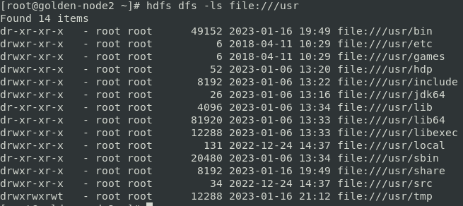

Use the HDFS Shell to list files and directories in HDFS.

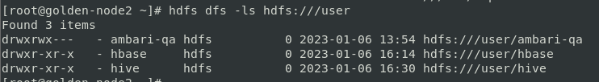

List files and directories in the HDFS root (/) directory

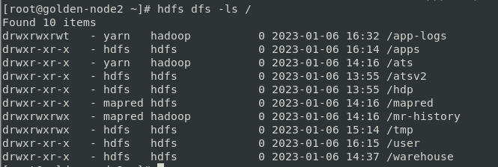

Switch to the HDFS superuser account and create the root user’s home directory using the command sequence shown below

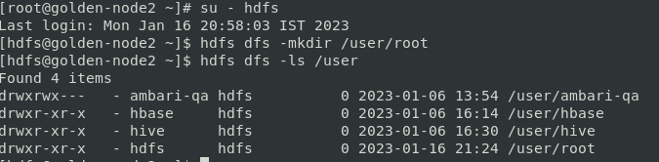

Create a subdirectory hierarchy in the root user’s HDFS home directory

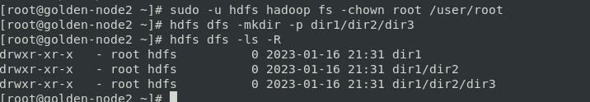

Copy the file constitution.txt from the local file system to the root user’s HDFS home directory. Then list the root user’s HDFS home directory to verify that the file was copied

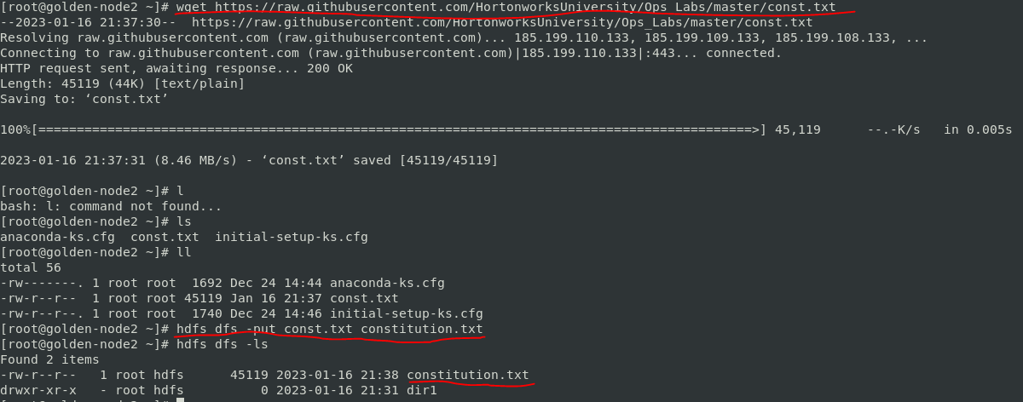

Display the contents of constitution.txt

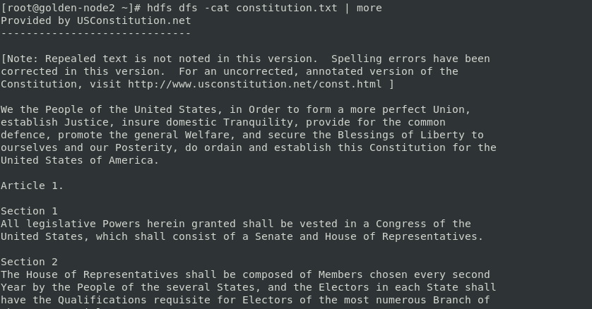

Copy the constitution.txt file from the root user’s HDFS home directory to the root user’s home directory in the local file system. Then list the root user’s home directory in the local file system to verify that the file was copied

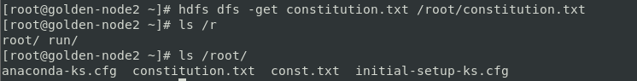

Move the constitution.txt file in the root user’s HDFS home directory to the HDFS directory /user/root/dir1/dir2/dir3

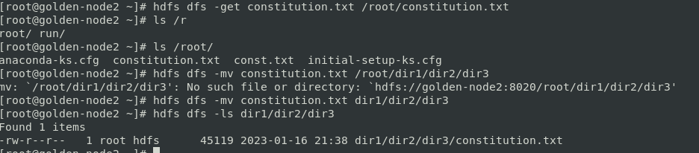

.Copy the local files /etc/passwd and /etc/hosts to the root user’s HDFS home directory. Then copy these two files back to the root user’s home directory on the local file system, ensuring that during the copy process the files are merged into a single file named passwd_hosts. Then view the contents of the merged file to verify that the process properly completed

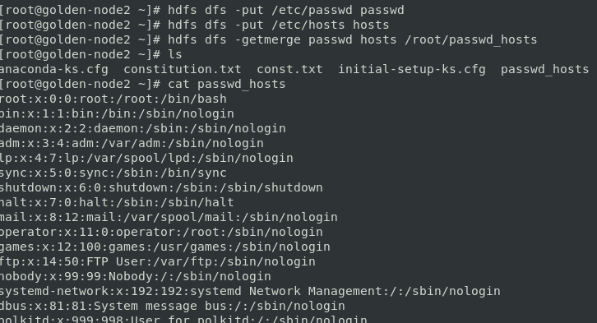

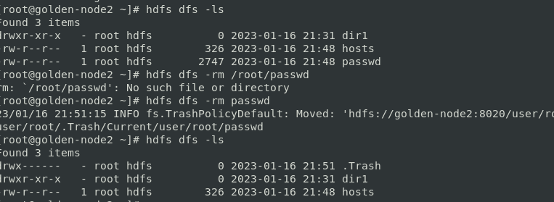

Recursively list the contents of the root user’s HDFS .Trash directory

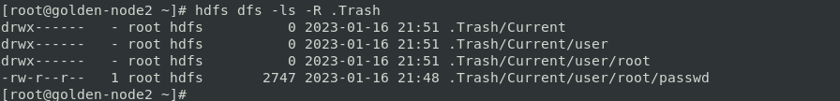

**Overriding Default HDFS Properties**





**Configuring Ambari Files View**

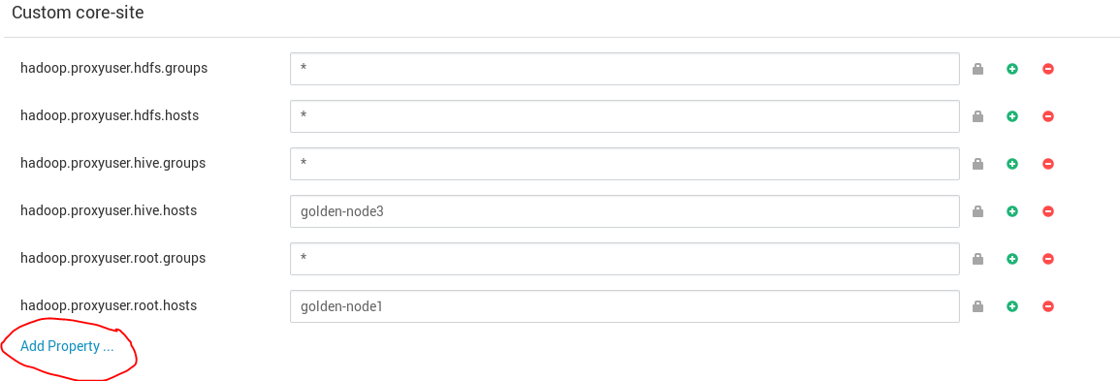

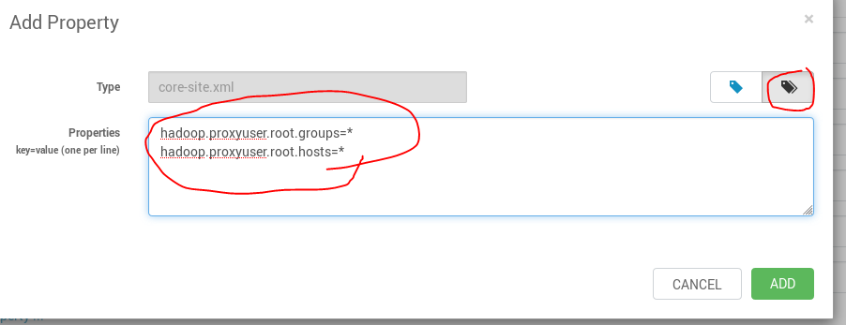

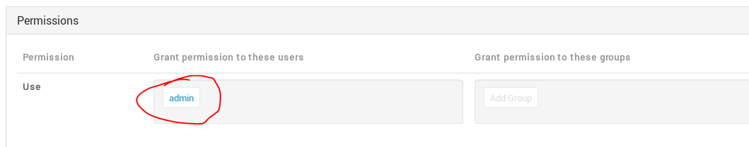

Use SSH login to any cluster node, create the HDFS home directory /user/admin for the admin user account. You will need HDFS superuser privilege to create this home directory.

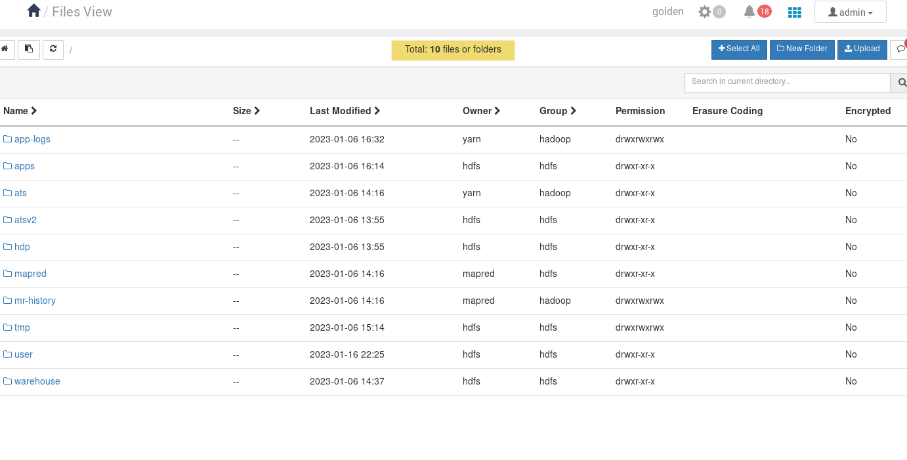

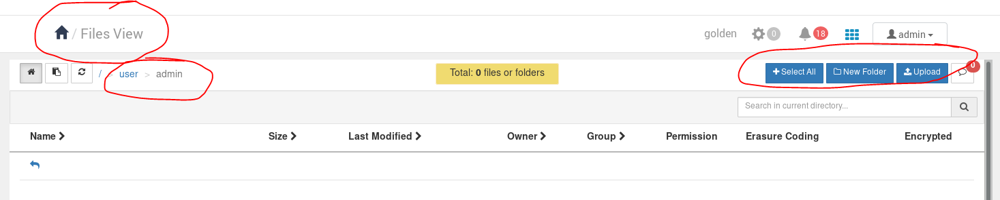

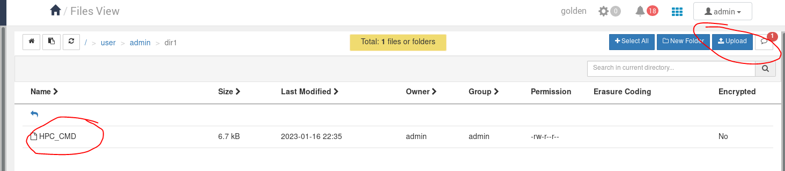

**Using the NameNode UI File Browser**



